Training Tokenizer on custom dataset for LLMs

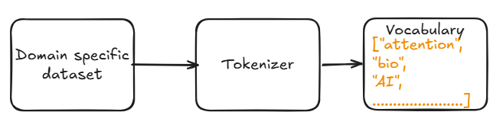

Why tokenizer?
LLM does not understand human-language, It only understand numbers. Therefore,
- We split the input text/sequence into smaller part called “tokens”.
- The tokenizer will assign a unique numerical IDs to each tokens.
- These token IDs are then passed to LLM for processing.
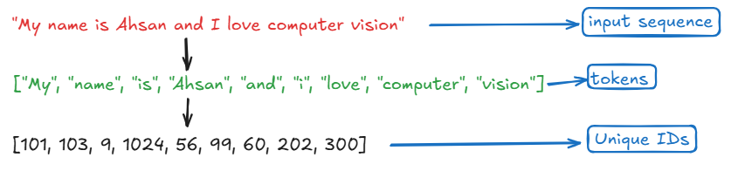
Types of Tokenizer:
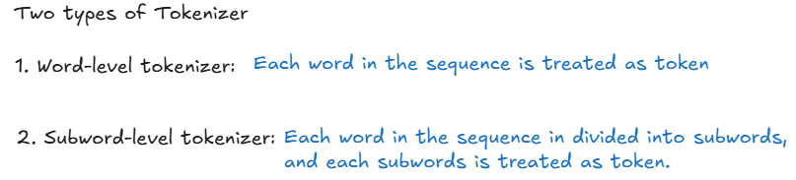

Disadvantage of Word-level Tokenizer:
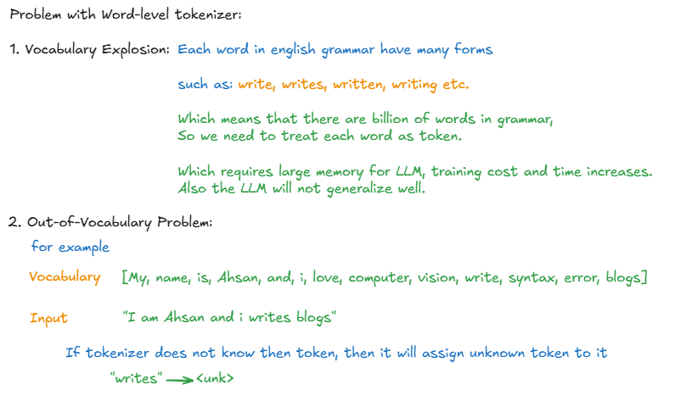

Sub-word Tokenizer:
